**Procedures**

Objectives

At the end of this session, the student will be able to:

* Create a stored procedure
* Alter and drop stored procedure
* Use parameter in stored procedure

Student uses SELL_MANAGE database to do this exercise. Database diagram is shown the following figure 1.

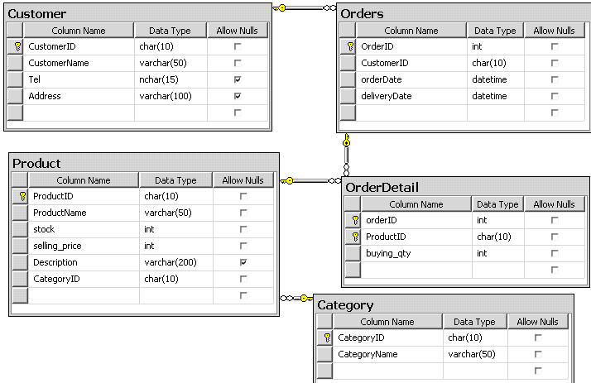

**Write the SQL statements to:**

1. Create a stored procedure named Cust_Proc that will list all customers which do not have telephone.
2. Create a stored procedure named PriceIncrease that will increment the selling price

of all items by 10 percent.

1. Execute the stored procedure Cust_Proc and PriceIncrease.
2. Now, view the definition of the PriceIncrease stored procedure by using sp_helptext system stored procedure.
3. Create a stored procedure named stockupdate that will update stock of given item by a given quantity.
4. Create a stored procedure to update delivery date of given order. If delivery date is less than order date in order then display error message. Otherwise, procedure will update delivery date of that order.
5. Modify the PriceIncrease stored procedure such that it additionally returns the number of rows updated. (Hint: using @@ROWCOUNT)
6. Modify the Cust_Proc stored procedure such that it calls the PriceIncrease stored procedure within it.
7. Remove all the stored procedures that were created so far.